Dasyophthalma (Lepidoptera: Nymphalidae: Satyrinae): systematics, distribution, and conservation perspectives of a butterfly genus endemic from the Brazilian Atlantic Forest

AUGUSTO H. B. ROSA, EDUARDO P. BARBOSA, PATRÍCIA A. MACHADO, RICARDO R. SIEWERT & ANDRÉ V.L. FREITAS

Supplementary file S1
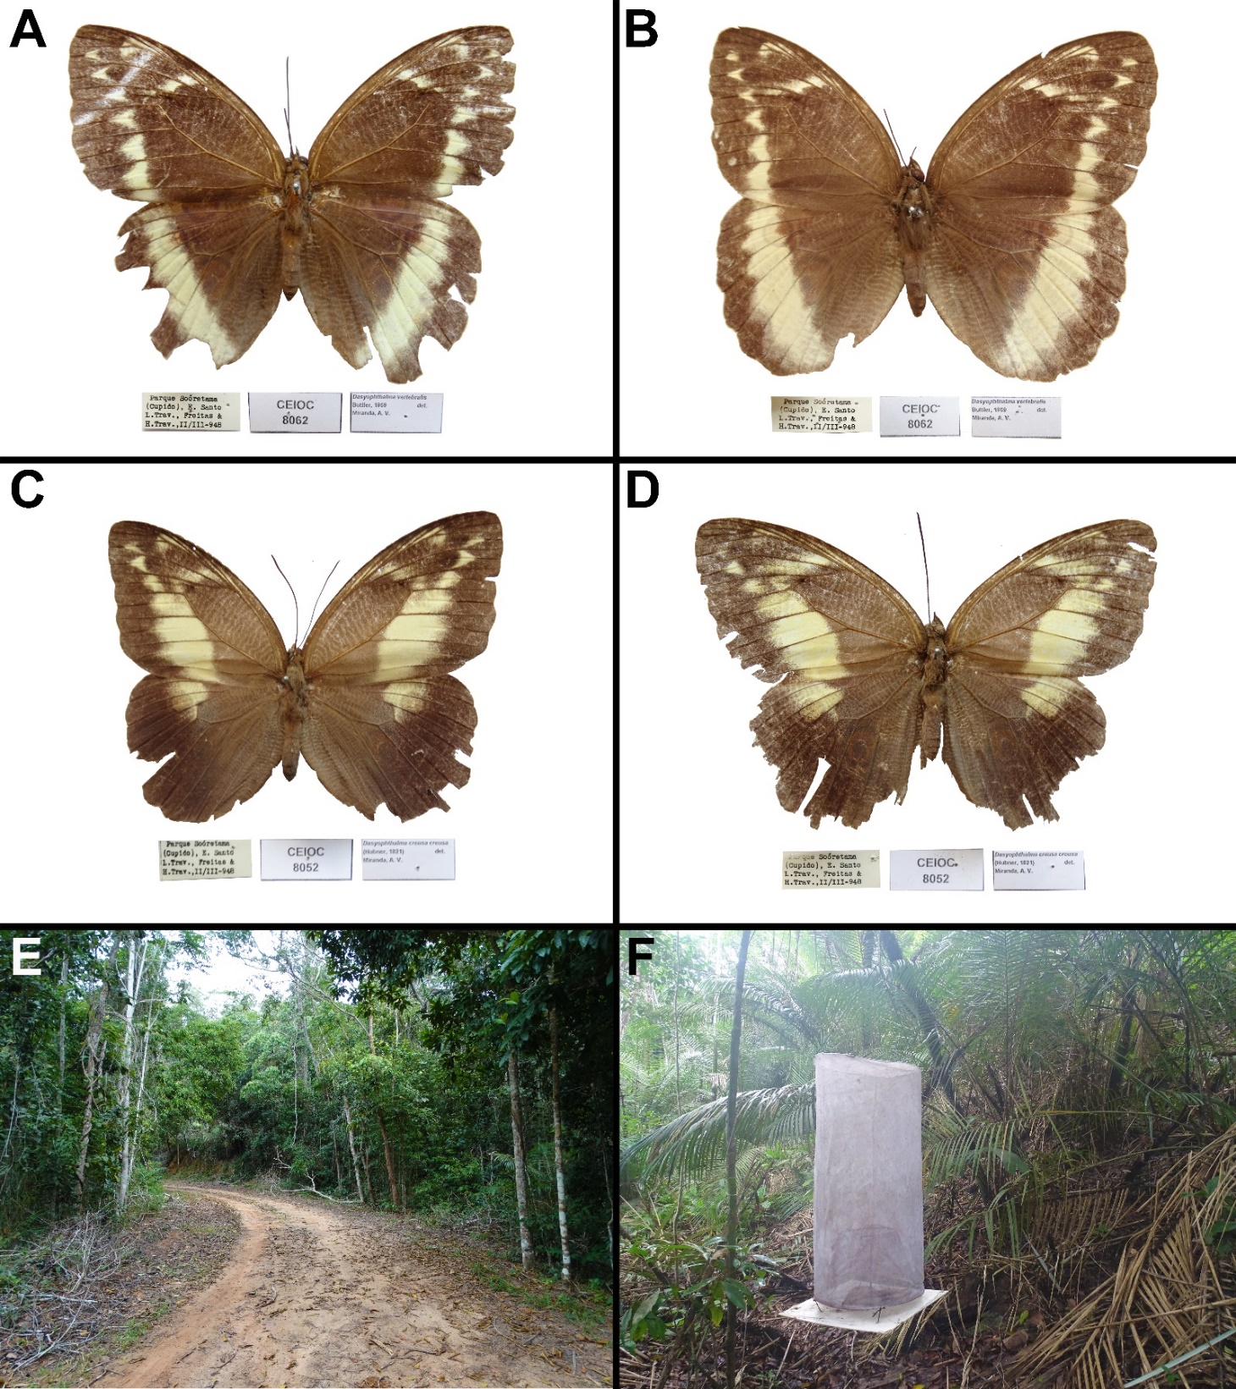
Figure S1. Adults and habitat of Dasyophthalma vertebralis and D. creusa from Sooretama Biological Reserve (SBR), Sooretama, Espírito Santo state. A, B. The two D. vertebralis female specimens from CEIOC collection; C, D. Two D. creusa female specimens from CEIOC collection; E. Closer view of D. vertebralis and D. creusa habitat on a road of SBR; F. attractive traps in the interior of forest of SBR.

Table S1. Abundance data of D. creusa and D. rusina
Species | N | Sampling duration | Reference
D. creusa | 81 | 7 months | Uehara-Prado et al. (2007)
 | 9 | 3 months | Gonzales (2008)
 | 51 | 4 months | Teixeira (2008)
 | 3 | 3 months | Nogueira (2012)
 | 9 | 12 months | Corso & Hernández (2012)
 | 1 | 15 months | Santos (2012)
 | 3 | 6 months | Giovenardi (2014)
 | 1 | 7 months | Pérez et al. (2019)
 | 1 | 6 months | Maciel et al. (2020)
 | 12:25 | 12 months | AHBR unpublished data¹
 | 14:26 | 12 months | AHBR unpublished data²
 | 30:5 | 10 years | AVLF unpublished data³
D. rusina | 1 | 7 months | Uehara-Prado et al. (2005)
 | 1 | 6 months | Giovenardi (2014)
 | 7 | 12 months | Silva et al. (2015)
 | 3 | 4 months | Pereira et al. (2017)
 | 5 | 12 months | Diniz & Silva et al. (2019)
 | 3:8 | 12 months | AHBR unpublished data¹
 | 1:2 | 10 years | AVLF unpublished data³
When available, sex ratio is showed as males:females; ¹ = Trabijú Municipal Natural Park, Pindamonhangaba, São Paulo state; ² = Forest fragment, Taubaté, São Paulo state; ³ = Serra do Japi, Jundiaí, São Paulo state.

References
Corso G, Hernández MIM (2012) Borboletas frugívoras da Mata Atlântica no Parque Estadual da Serra do Tabuleiro, Santa Catarina, Brasil. Biotemas 25(4): 139–148. https://doi.org/10.5007/2175-7925.2012v25n4p139

Giovenardi R (2014) Composição de Lepidoptera (Papilionoidea e Hesperioidea) do Rio Grande do Sul e variabilidade espaço-temporal em três áreas no norte do estado, Brasil. Doctoral degree Thesis, Universidade Federal de Santa Maria, Santa Maria, Rio Grande do Sul, Brasil.

Gonzales WRS (2008) Diversidade de borboletas Nymphalidae no Parque Municipal da Lagoa do Peri: espécies de floresta ombrófila densa, de restinga e de áreas reflorestadas com pinus. Monograph of graduation, Universidade Federal de Santa Catarina Florianópolis, Santa Catarina, Brazil.

Maciel TT, Barbosa BC, Santos-Prezoto HH, Aguiar JA, Prezoto F (2019) Advances in catching fruit butterflies for quick inventory. Scientia Plena, 15(12): 122401–1. https://doi.org/10.14808/sci.plena.2019.122401122401

Nogueira TA (2012) Análise da diversidade e efeito de borda na assembléia de borboletas frugívoras da Reserva Biológica de Sooretama–ES. Master degree Thesis Universidade Federal do Espírito Santo, Vitória, Espírito Santo, Brazil.

Pereira GCN, Coelho MS, Beirão MDV, Braga RF, Fernandes GW (2017) Diversity of fruit-feeding butterflies in a mountaintop archipelago of rainforest. Plos One, 12(6): 1–20, e0180007. https://doi.org/10.1371/journal.pone.0180007

Pérez JH, Carneiro E, Gaviria-Ortiz, FG, Casagrande MM, Mielke OHH (2019) Urban landscape influences the composition of butterflies in public parks and fragments in Southern Brazil. Community ecology, 20(3): 291–300. https://doi.org/10.1556/168.2019.20.3.9

Santos S (2012) Proposta de protocolo de monitoramento utilizando borboletas frugívoras (Lepidoptera: Nymphalidae) como indicadores de impacto ambiental na Reserva Biológica União/RJ. Master degree Thesis, Universidade Federal do Rio de Janeiro, Rio de Janeiro, Rio de Janeiro, Brazil.

Silva ARM, Pontes DV, Guimarães MP, Oliveira MVD, Assis LTFD, Uehara-Prado M (2015) Fruit-feeding butterflies (Lepidoptera: Nymphalidae) of the Área de Proteção Especial Manancial Mutuca, Nova Lima and Species list for the Region of Belo Horizonte, Minas Gerais, Brazil. Biota Neotropica, 15(3): 1–9, e20140118. https://doi.org/10.1590/1676-06032015011814

Silva VDE, Beirão MV, Cardoso DC (2020) Thermal tolerance of fruit-feeding butterflies (Lepidoptera: Nymphalidae) in contrasting mountaintop environments. Insects, 11(5), 278.

Teixeira MO (2008) Diversidade de Borboletas frugivoras e avaliação do uso de armadinhas atrativas associadas a marcação e recaptura em ambientes de Mata Atlântica Maquiné, RS, Brasil. Master degree Thesis, Universidade Federal do Rio Grande do Sul, Porto Alegre, Rio Grande do Sul, Brasil.

Uehara-Prado M, Brown Jr. KS, Freitas AVL (2005) Biological traits of frugivorous butterflies in a fragmented and a continuous landscape in the South Brazilian Atlantic Forest. Journal of the Lepidopterists’ Society, 59: 96–106.

Uehara‐Prado M, Brown Jr. KS, Freitas AVL (2007) Species richness, composition and abundance of fruit‐feeding butterflies in the Brazilian Atlantic Forest: comparison between a fragmented and a continuous landscape. Global Ecology and Biogeography, 16(1): 43–54. https://doi.org/10.1111/j.1466-8238.2006.00267.x

